UPVC Design

User Documentation

# **Introduction**

Welcome to the user manual for UPVC door and window designs! This manual is designed to provide you with all the information you need to know about the various UPVC door and window designs available on our website. Whether you are a homeowner, an architect, a contractor, or a builder, this manual will help you understand the features, benefits, and installation requirements of our UPVC designs.

UPVC (unplasticized polyvinyl chloride) is a versatile and durable material widely used for making doors and windows. UPVC doors and windows are energy-efficient, low-maintenance, and weather-resistant, making them a popular choice for homes, offices, and commercial buildings. At our website, we offer a wide range of UPVC door and window designs, from traditional to modern, to suit your style and budget.

This manual is divided into several sections, each focusing on a specific aspect of UPVC door and window designs.

Following are the UPVC designs available on our website:

1. Door Design
2. Sliding Windows
3. Draw Design

**Note: The blue border in snapshots highlights that specific point.**

# **Door Design**

The door design consists of three subsections:

1. Single Door
2. Double Door
3. 2H Door

Before starting the door design, the very first thing, we need to do is to assign height and width for the door. The input fields for assigning height and width are given at the left side of the page. After giving height and width to the design, you will be ready to go with the door design. The door design consists of different things like top Hung, shape of the panels, type of Top Hung (i.e. Openable, fixed or Sliding). You can select number of top hungs from select Top Hung Dropdown. After selecting number of top hungs, you will need to assign some height to top Hung as well from the input field given on the left side of the page. When you select the number of top hungs, the input field for assigning height top top hung will be highlighted with a red border around it, so you can easily find it there in the input fields section, the type of top hung can be selected from Type dropdown. You can also put an arch on the door by clicking on the arch icon given in the design. You will need to click on the top hung section of the door if you want to put an arch in the design. If you want to remove the arch from the design, just click on the arch icon in the design and then click on the arch design. The arch design will be marked red if is already selected and will be marked black if it is not selected. You can adjust the width of each panels and each top hungs from top hung width and panel width input field given at the end of input fields at the left side of the page. The door design also has the functionality of either putting the panel leaf or not if you want to put it in the design, you will need to select it from the panel/leaf dropdown given in the input field section. After selecting the panel leaf, you will need to assign some height to it as well from the glass height input field. You can also select the door base to be there in the door or not by selecting it from the dropdown given in the following snapshot

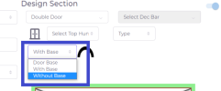

Fig (1.1)

1. **Single Door:**

The single door design consists of only one panel and you can the shape of the panel from the drop down given in Fig (1.2). The shape of the panel shows whether it is openable from left or right.

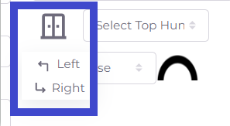

Fig (1.2)

1. **Double Door:**

The double door design will have two panels. You can select design of each panel as you want i.e. left door, right door, fixed door, left Glass and right Glass door. You can select shape of each panel by selecting it from the dropdown given in the following snapshot.

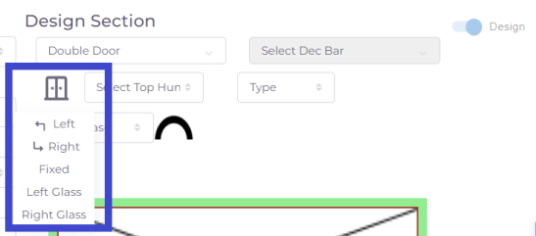

Fig (1.3)

The double door design is given in the following snapshot.

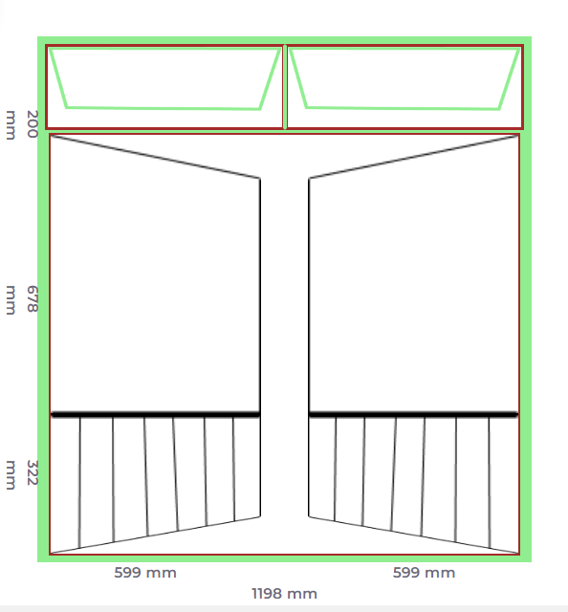

Fig (1.4)

1. **2H Door:**

The 2H Door design is the same as single door but the difference is that the 2H door has no top hung instead it has a triangular design in place of top hung. The shape of the triangle may be from or right. You can select the triangle shape from the button given in the design. The buttons are given in Fig (1.5)

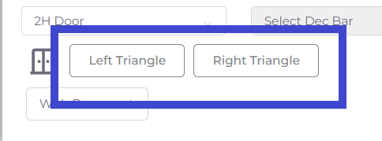

Fig (1.5)

# **Sliding Windows**

There are four type of sliding windows i.e. 2PSL, 3PSL and 4PSL. These type can be selected from the Select Window Dropdown given in Fig (1.6)

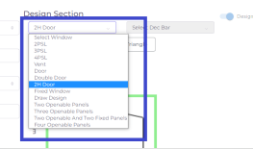

Fig (1.6)

All 2PSL, 3PSL and 4PSL are working the same, the only difference is that 2PSL has two panel, 3PSL has three and 4PSL has four panels. They are the sliding windows and their panel may be fixed/sliding. The type of the panels can be selected from the drop down given in Fig (2.1). You can also put a sash in the panel from sash drop down (see Fig 2.2). The decorative bar will be disabled but when you change the beading to DG from beading dropdown in the input field section, it will enable the decorative bar and you can select a decorative bar of your own choice from the decorative bar dropdown. The panel with sash is given in Fig (2.3).

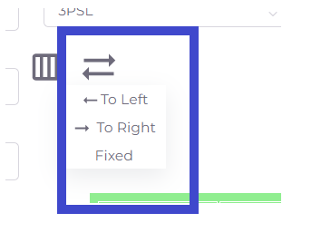

Fig (2.1)

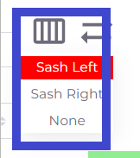

Fig (2.2)

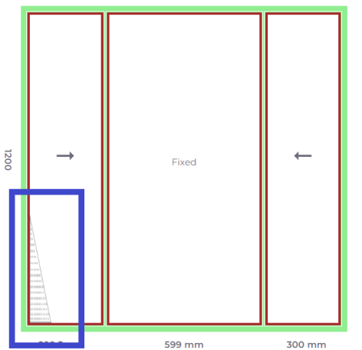

Fig (2.3)

# **Draw Design**

From the draw design section, you can make a design of your own choice. You can make openable, fixed or sliding design from this section. firstly, we need to assign height and width to the design. The input fields for assigning height and width are given at the left side of the page. After giving height and width to the design, you will be ready to go with the draw design. The draw design consists of different things like top Hung, shape of the panels, type of Top Hung (i.e. Openable, fixed or Sliding). You can select number of top hungs from select Top Hung Dropdown. After selecting number of top hungs, you will need to assign some height to top Hung as well from the input field given on the left side of the page. When you select the number of top hungs, the input field for assigning height to top hung will be highlighted with a red border around it, so you can easily find it there in the input fields section, the type of top hung can be selected from Type dropdown. You can also put an arch in the design by clicking on the arch icon given in the design. You will need to click on the top hung section of the door if you want to put an arch in the design. If you want to remove the arch from the design, just click on the arch icon in the design and then click on the arch design. The arch design will be marked red if is already selected and will be marked black if it is not selected. You can adjust the width of each panels and each top hung from top hung width and panel width input fields given at the end of input fields at the left side of the page. In the draw design, you will have an icon given in Fig (3.1) from where you can select the number of Panels. You can select the shape of panel from the dropdown given in Fig (3.2). In draw design, you can add or remove mullions by clicking on the add/remove button from the design (see Fig 3.3). There is also a dropdown for selection of sash so if you want to put sash in your design, you can easily do it from there. The decorative bar will be disabled but when you change the beading to DG from beading dropdown in the input field section, it will enable the decorative bar and you can select a decorative bar of your own choice from the decorative bar dropdown.

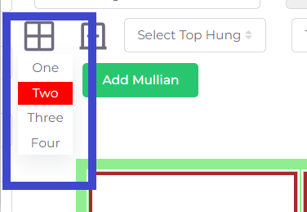

Fig (3.1)

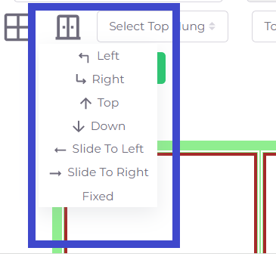

Fig (3.2)

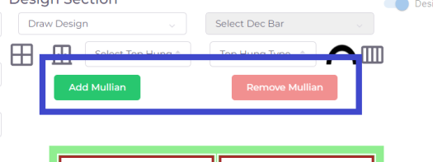

Fig (3.3)

We hope that this manual will help you make an informed decision about choosing the right UPVC door and window design for your building. If you have any questions or need further assistance, our support team is always ready to help you.